Chukwuebeka Ezema

Neti Sheth

Josh Stamper

Yagna Venkitasamy

Team Enjoy!

Pivot and Apply Operators, UDF, Except/Intersect

**Table of Contents**

|  |  |  |
| --- | --- | --- |
| **S. No**  **Part 1:** | **Content** | **Page. No** |
| 1 | Create a UDF scalar | 2 |
| 2 | Create a UDF Table Valued | 2 |
| 3 | Call function from select statement |  |
| 4 | Create a SPROC that Calls UDF, Execute SPROC | 3 |
| 5 | Produce Select statement result using Apply operator | 4 |
| 6 | Demonstrate use of Intersect and Except Operators | 4 |
|  |  |  |
| **Part 2:** |  |  |
| 1 | Create a pivot table from a current table. |  |
| 2 | Unpivot the table to a new table |  |
| 3 | Must support a user story and reporting requirement. |  |
|  |  |  |
|  |  |  |
|  |  |  |
|  |  |  |
|  |  |  |
|  |  |  |

**Part 1:**

* Create a UDF Scalar
* Create a UDF Table valued

**User story:** Academic advisor wants a report to view individual student performance in the enrolled courses.

* UDF Table valued
* The value requested from the user is the StudentID, this allows the function to return all courses taken by a particular student

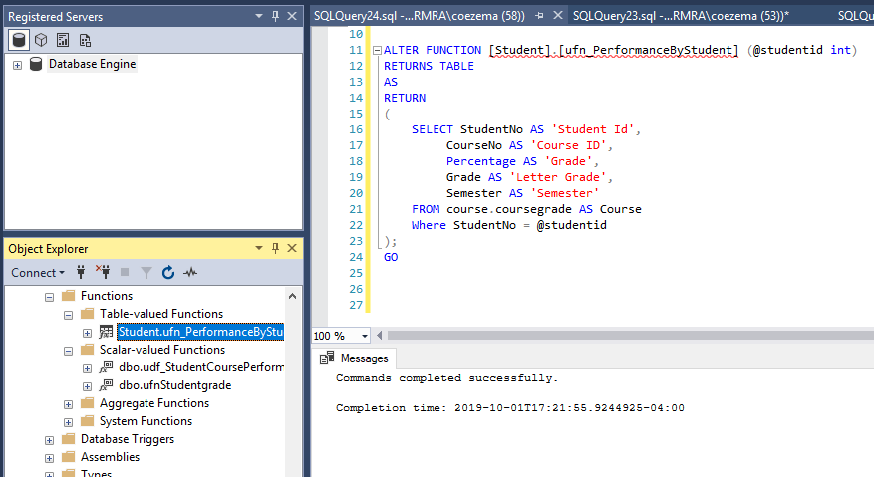

* UDF Scalar with 1 and 2 parameters
* The parameter requested is StudentNo for the ufnStudentGrade UDF
* The parameters requested are CourseNo and StudentNo in the ufnStudentCourseFunction UDF

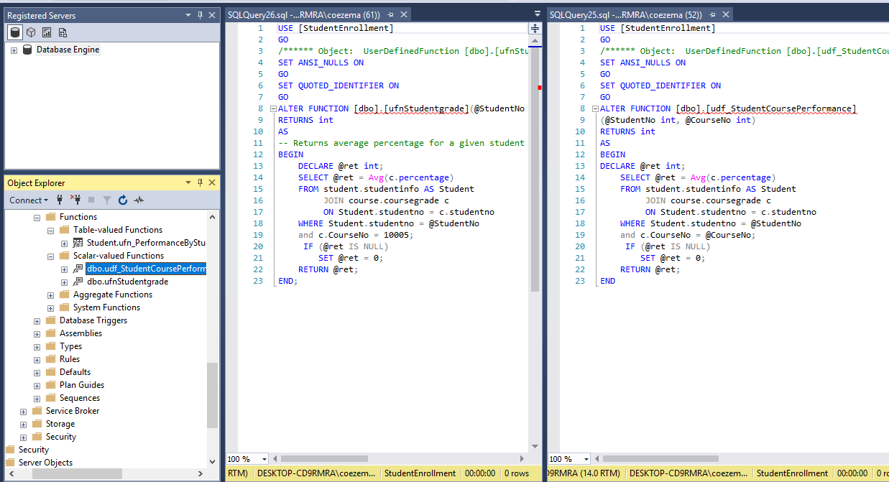

* Call function from select statement

User Story:

As the Academic Advisor I want to know the classes a student took and their major,

so that I can advise the appropriately for the next semester

This query calling the ufn_PerformanceByStudent function returns the coursework for StudentID 1.

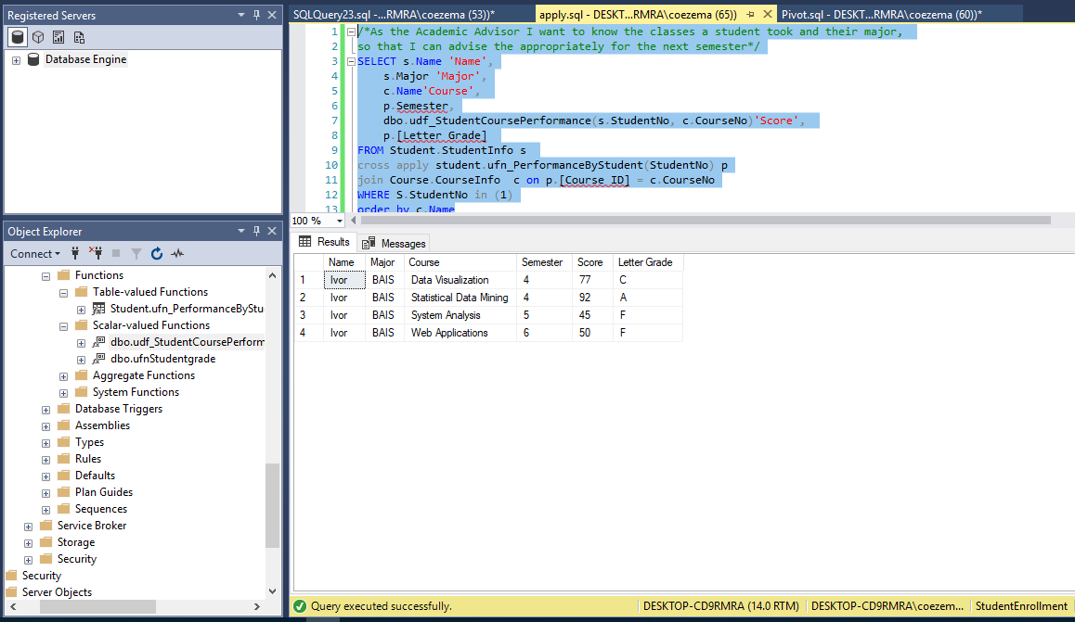

* 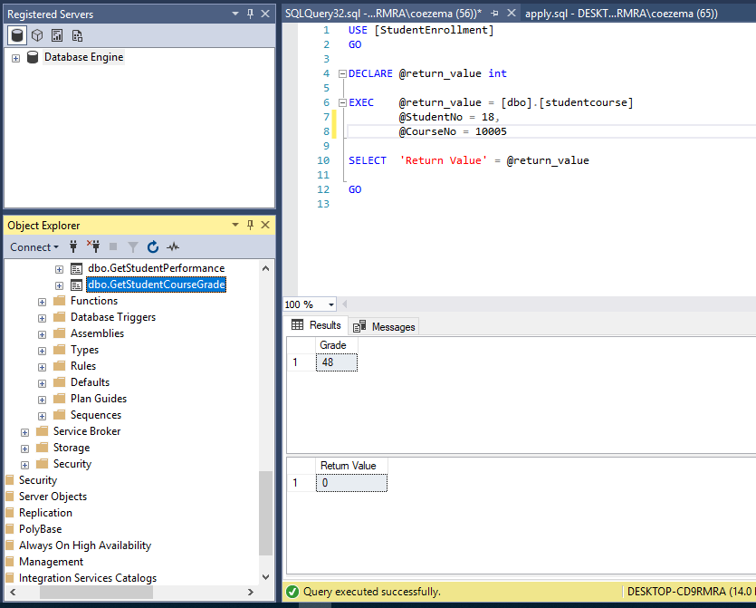  Create a SPROC that Calls UDF, Execute SPROC
* Produce Select statement result using Apply operator

The cross apply operator of the three compared is quite is similar to the inner join operator. It produced the same results whereas the left/right and Full produced vastly different results.

While either inner or cross apply would work the preferred method would be to use cross apply when using UDF.

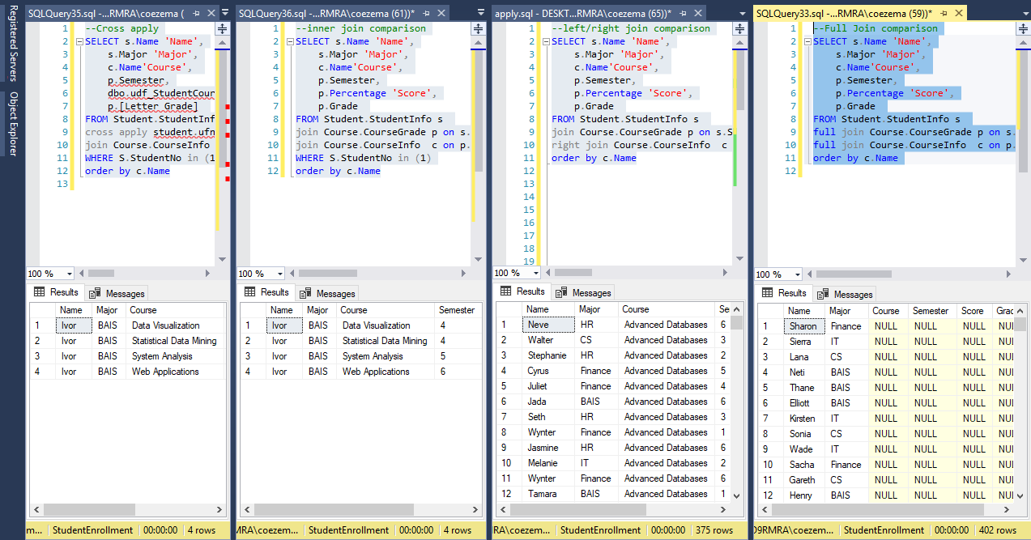

* Demonstrate use of Intersect and Except Operator

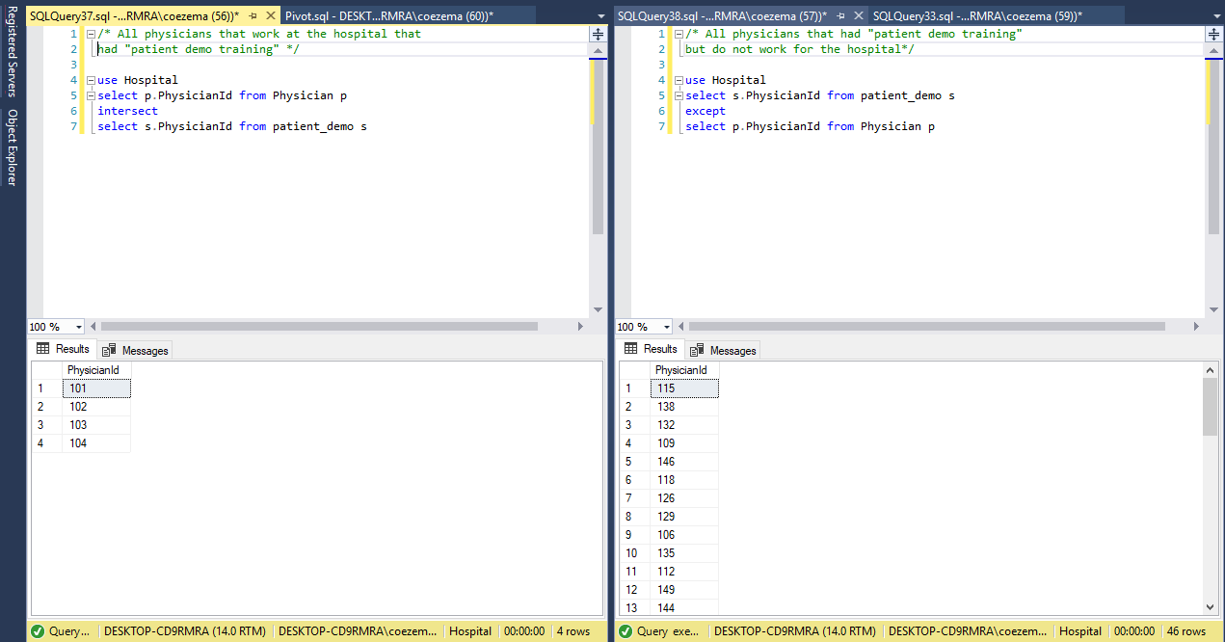

Part 2:

* Create a pivot table from a current table.

User Story: As a Program Director, I want to know the grade distribution for all the courses offered

so that I can recommend additional TA's for course with higher number of failing grades

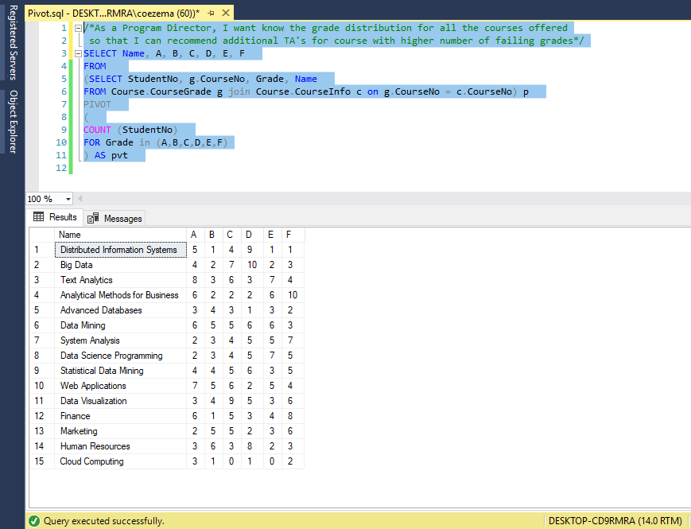

* Unpivot the table to a new table

User Story: As a Program Director, I want to know the grade distribution for all the courses offered so that I can recommend additional TA's for course with higher number of failing grades

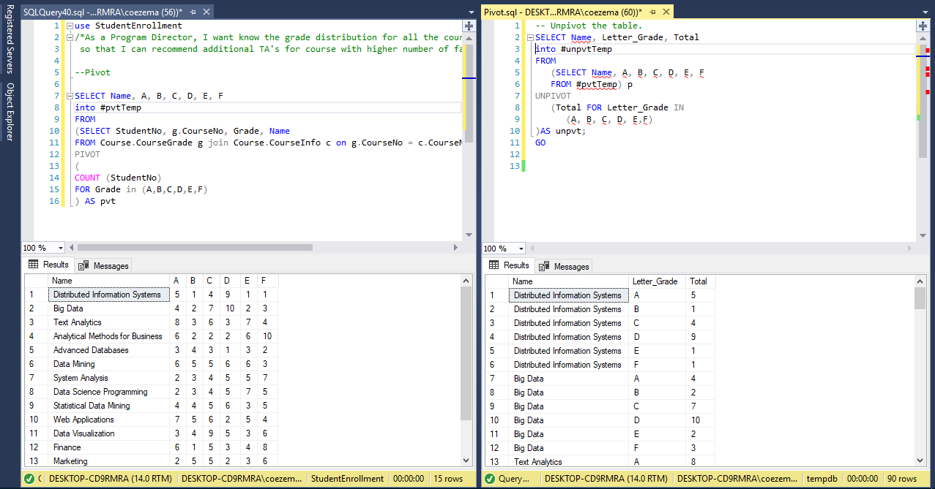

CROSS- APPLY UNPIVOT

User Story: As a Program Director, I want to know the grade distribution for all the courses offered

so that I can recommend additional TA's for course with higher number of failing grades

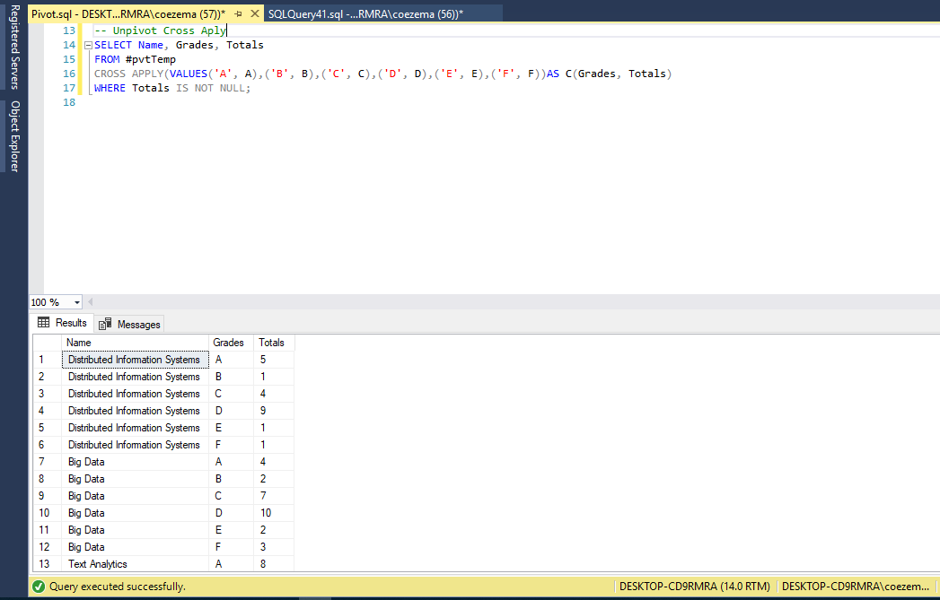

CROSS- JOIN PIVOT

User Story: As a Program Director, I want to know which professor to assign to a course for the upcoming semester

